**Preparation of Academic Article for The 15th BENJAMIT Network National & International Conference**

**Title**< Times New Roman, 12 point, Bold>

**Author’s Full Name (**e.g. **First Name Last Name1, First Name Last Name2 and**

**First Name Last Name3)**<Times New Roman, 11 point, Bold>

1Full Address (Department, Faculty, University, City, Country)<11 point, Normal>

2 Full Address (Department, Faculty, University, City, Country)

3 Full Address (Department, Faculty, University, City, Country)

**Abstract**

The instructions below are specially directed at author(s) who wish to submit a manuscript to Knowledge Integration to Sustainable Development. The manuscript must be clear and its format must be consistent with the other papers included in the conference CD-ROM proceedings. Use this document as a template if you are using Microsoft Word 2010. Otherwise, use this document as an instruction set.

***Keywords****:* Two to four keywords should be provided here to assist with indexing of the article.

**Introduction**

(This is an introduction and background to provide readers with basic information about the content. It motivates readers to be interested in that topic.) This document is prepared to be a guide for writing a full article. It will specify both the format and guidelines for printing the article, which will be the same format used for preparing conference documents in CD format. After the article has been considered by the committee for presentation at the conference, the submitter must prepare and submit the complete article in “PDF File” and “Microsoft Word File” formats. In order to create a standard document, the submitter should print the article strictly according to the specified format and guidelines.

The full article should include the title of the article, name and address of the author, abstract, key words, complete content of the article, acknowledgment and reference documents. By the content of the article can be divided into main topics, sub-topics and may be divided into sub-topics. All letters used in every section are typed using the Time New Roman font. The distance between the lines is single line and each page does not have to fill in the page number.

The size of the paper used in printing is set to A4 standard size (8¼ 11¾ inches. By the other parts of article except the title of the article, name and address of the author, abstract and keywords, typing by setting the page settings as follows

Top edge of the paper 25 mm.

Bottom edge of the paper 20 mm.

Left edge of the paper 25 mm.

Right edge of the paper 20 mm.

The overall length of the article should be in the range of 8 - 10 pages of paper.

Putting references at the beginning of a sentence, such as “Deejai (2022) Learning can always be learned, so we can develop further.” Putting references at the end of a sentence, such as “Learning can always be learned, so we can develop further. (Deejai, 2022).”

**Content**

(This is the main part of the article. Content sequencing should be planned and structured to be appropriate for the nature of the content. Content presentation should be continuous to help readers easily understand the content. It can be arranged in order according to the details of the content and can be divided into sub-issues as appropriate.) Presentation of pictures and tables can be presented from the message mentioned or may be presented after the end of the topic or presented on the new page.

Both images and tables must have an explanation. By the description of the image, type it under the picture and centered on the page. If any image is divided into 2 parts, the description of each part will be specified by using English in brackets, in order such as (a) and (b). As for the table description, type above the table and align the left edge of the column or align the left edge of the paper by sorting pictures and tables to separate the order from each other.

Specifying the sequence number, picture and table in the article, specify as figure 1 or table 1, etc.

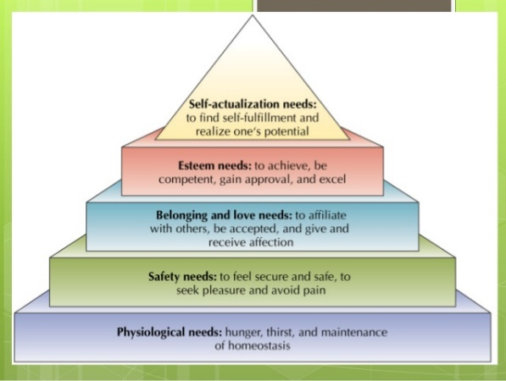

Figure 1 Maslow's motivation theory

Note : From “Maslow's General Theory of Human & Motivation” by ….., year, Journal Title,/ Volume (issue),/p. Page Number

Table 1 shows the average standard deviation and the level of opinion, the results of operations in the Active Learning teaching and learning management

|  |  |  |  |
| --- | --- | --- | --- |
| Evaluation list | Evaluation | | |
|  |  | Results |
| 1. System Evaluation  2. Evaluation of program preparation  3. Evaluation of program implementation  4. Evaluation for program improvement  5. Evaluation for program certification | 4.80  4.48  4.44  1.38  4.50 | 0.874  0.290  0.271  0.373  0.390 | high  Quite high  high  Low  high |

**Conclusion**

(This is a clear and concise summary of the content of the entire article, with a final summary of

the content you have presented, whether it has any positive or negative effects.)

**Reference**

(Example)

Becker, J. C. (2013). Landscape-level influences on community composition and ecosystem function in a large river ecosystem (Publication No. 3577776) [Doctoral dissertation, Graduate Council of Texas State University – San Marcos]. ProQuest Dissertations and Theses Global.

Leethochawalit, M. (2010). Development of learning process organization based on contemplative education approach for developing early childhood teachers in inclusive schools [Doctoral dissertation, Chulalongkorn University]. Chulalongkorn University Intellectual Repository (CUIR). http://cuir.car.chula.ac.th/bitstream/123 456789/19064/1/Manita_le.pdf

***Books*** *(Example)*

Mertens, D. M. (2014). Research and evaluation in education and psychology: Integrating

diversity with quantitative, qualitative, and mixed methods (4th ed.). Sage.

***Conference Technical Articles*** *(Example)*

Katz, I., Gabayan, K., & Aghajan, H. (2007). A multi-touch surface using multiple cameras. In J. Blanc- Talon, W. Philips, D. Popescu, & P. Scheunders (Eds.), Lecture notes in computer science: Vol. 4678. Advanced concepts for intelligent vision systems (pp. 97–108). Springer-Verlag. https://doi.org/ 10.1007/978-3-540-74607-2_9

***Website*** *(Example)*

Centers for Disease Control and Prevention. (2018, August 22). Preventing HPV–associated cancers. https://www.cdc.gov/cancer/hpv/basic_info/ prevention.htm

***Thesis and Dissertations*** *(Example)*

Jung, M. S. (2014). A structural equation model on core competence of nursing students [Unpublished doctoral dissertation]. Choong-Ang University.

**Other details**

Writing reference documents

To compile a list of publicationsand various knowledge materials used as evidence or references in the study at the end of the article. By referencing in the article content, use the APA7 format of referencing, which is writing a reference by name-year by stating the author's family name followed by the year of writing, such as Jaidee (2022), etc., arranged in order of reference before and after.

The references at the end of the article must be cited or mentioned in the article and arranged in the order of the references that appear in the article. Use the APA7 format of referencing by arranging the references, including alphabetical order. English Use the same principle as arranging words in the Dictionary by arranging them A-Z. Example: Villafuerte, S. A., before Villa-Lobos, J.

Checking before submitting articles

The person submitting the article must submit both in the form Time New Roman and PDF File. The author must check the correctness of the content before sending it to the organizer. Because if an error occurs, it must be the responsibility of the author.